Vectored Steering 1 Joystick to Drive lookup table

Introduction by Jørn for the Joystick Piloting Project.

I have decided on the following terminology for the Joystick Piloting Project:

|  |  |  |
| --- | --- | --- |
| Skid steering: | Differential steering: | Vectored steering: |
|  |  |  |

Skid steering and differential steering is based on this video: <https://www.youtube.com/watch?v=F3G0sUz3_Jw>

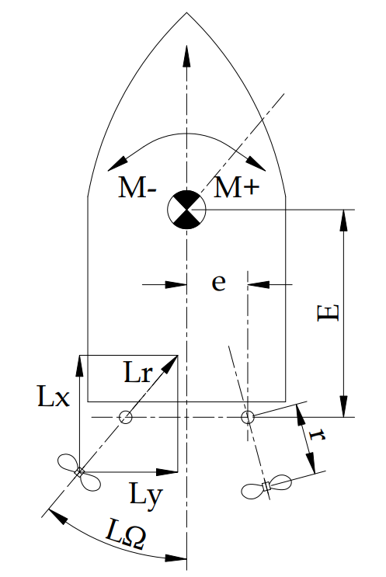

Formulas update 3rd May now also considering radius r from motor steering pivot point to propeller.

Variable and formula list:

Thrust force components:

Lr = Left engine resultant thrust, N. Pushing boat as shown is POSITIVE direction

LΩ = Steering angle Dgr. Clockwise as shown is POSITIVE direction.

Lx = Lr x Cos LΩ

Ly = Lr x Sin LΩ

Angular momentum M from thrust force around Center of Gravity CoG

E = Distance from CoG to steering pivot point in boat X-direction

e = Distance from CoG to steering pivot point in boat y-direction

r = Distance from motor steering pivot point to propeller center, same for both motors

Lever arm ( = moment arm) summary:

E’ = E + rx = E + r x Cos Ω

e’ = e + ry = e + r x Sin Ω

MLx = Lx x e’

MLy = Ly x E’

See Excel spreadsheet for final complete formulas and setup: “Skid Steering 1 Kendra Joystick to drive formula.xlsx”